**Additional PyMOL commands**

* **To save your work for another time**, on the top menu select “File” 🡪 “Save session as” navigate to a specific folder and save as a .pse file. You can then load the current state of your molecule in PyMOL at a later date.
* **Ugly looking surface/mesh when you select a section of the complex** eg. only the DNA portion of the nucleosome as below. See the regions where the protein contacts the DNA and the surface of the DNA is not shown as a closed surface.

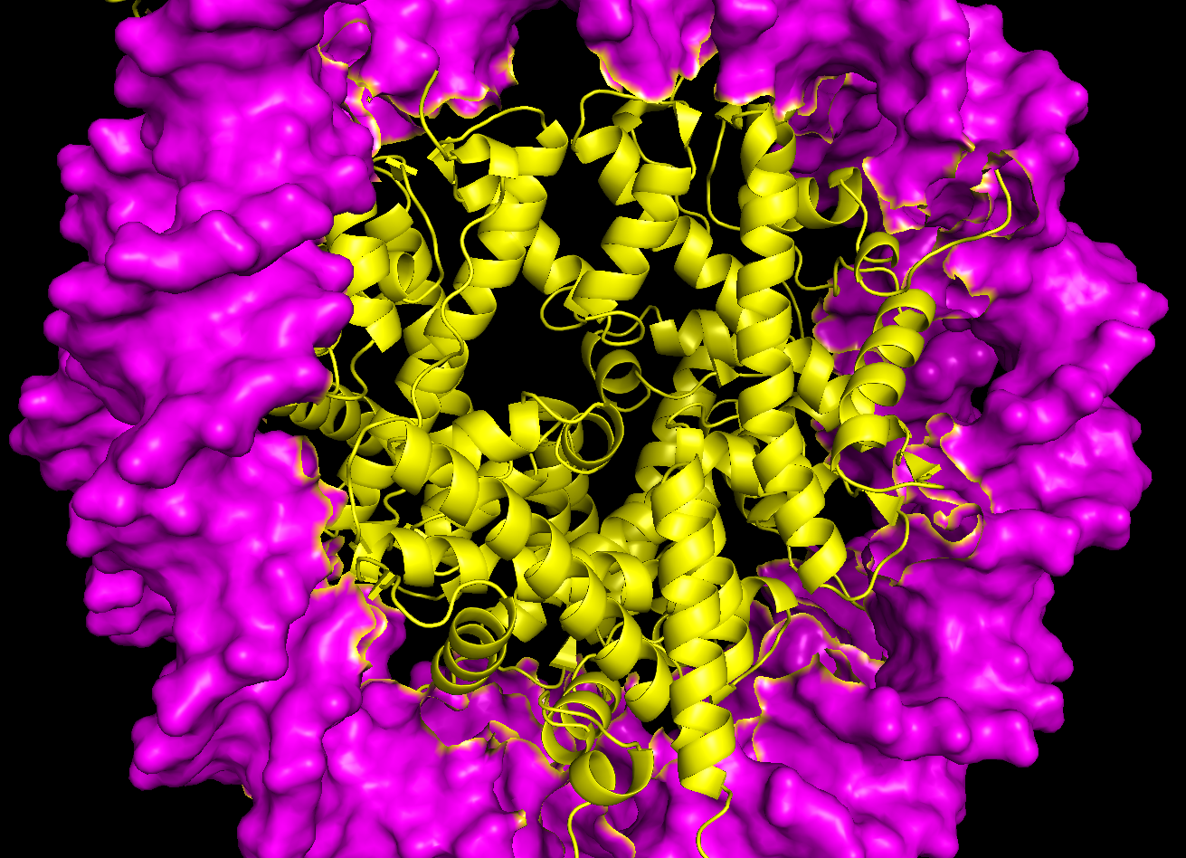

To make the surface of the DNA continuous without those missing portions, select the DNA in its entirety using the sequence bar.

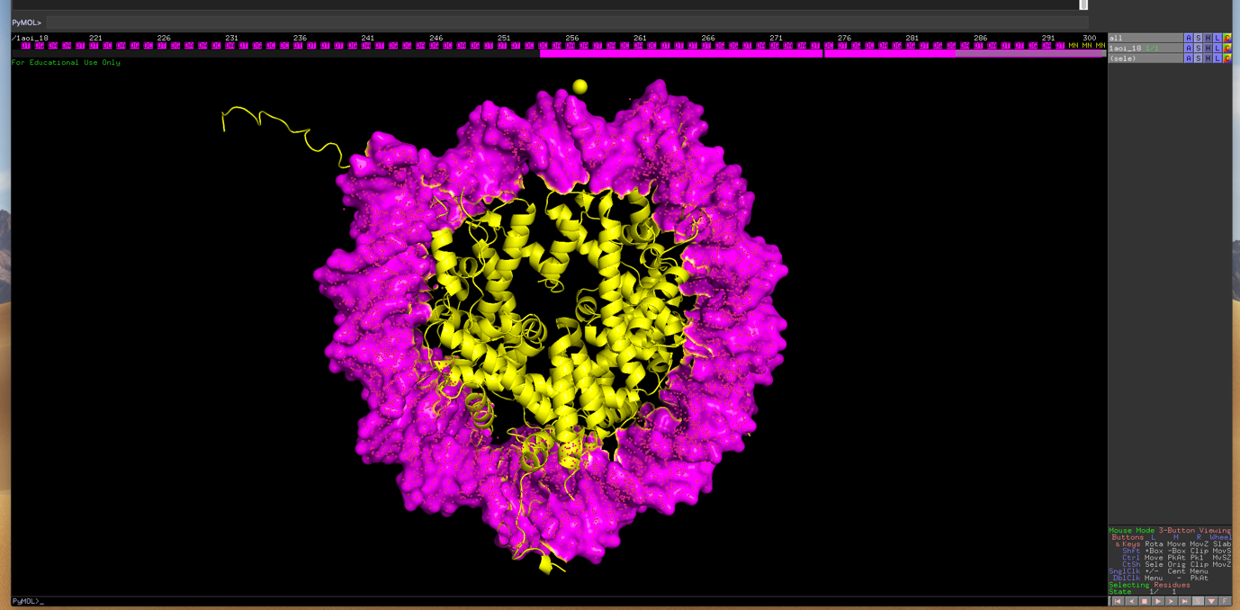

In the pymol command line bar above the sequence bar, type: “create DNA, sele” and press enter.

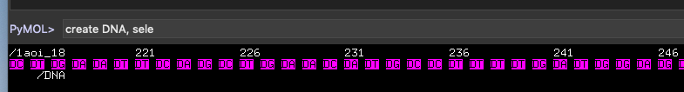

What this essentially means is to create a new object named “DNA” based on the atoms you’ve selected. A new item on the RHS panel should appear called “DNA” that only comprises of the DNA portion of the original nucleosome PDB file. If you were doing this for a specific protein you might instead want to type “create *\*insert protein name*\*, sele”

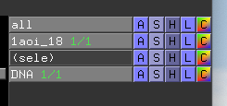

This will create a new object called DNA that only has the DNA portion of the nucleosome:

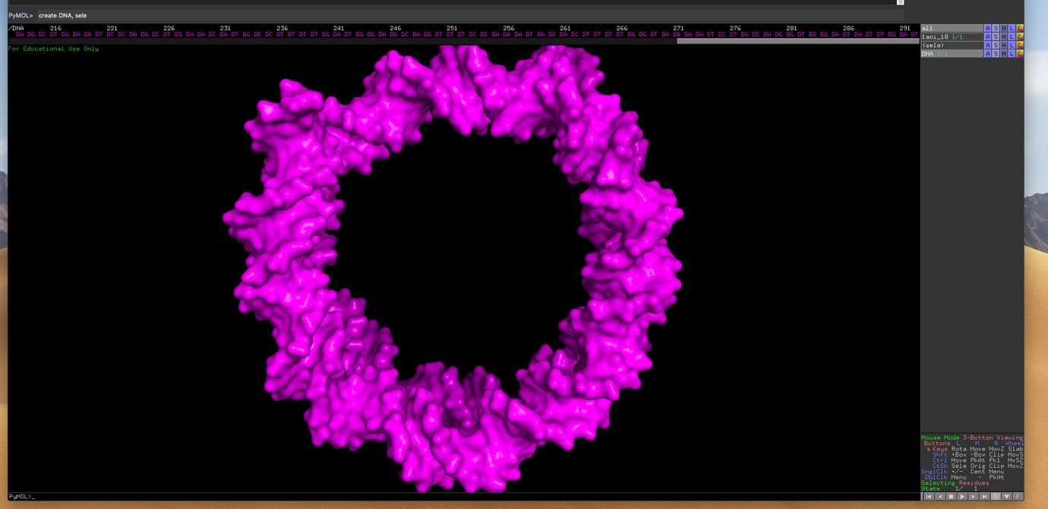

So now you can do two things. 1) you can select the DNA in the original PDB file loaded (mine is 1aoi_18) and delete these atoms by clicking on the “A” button next to the (sele) item:

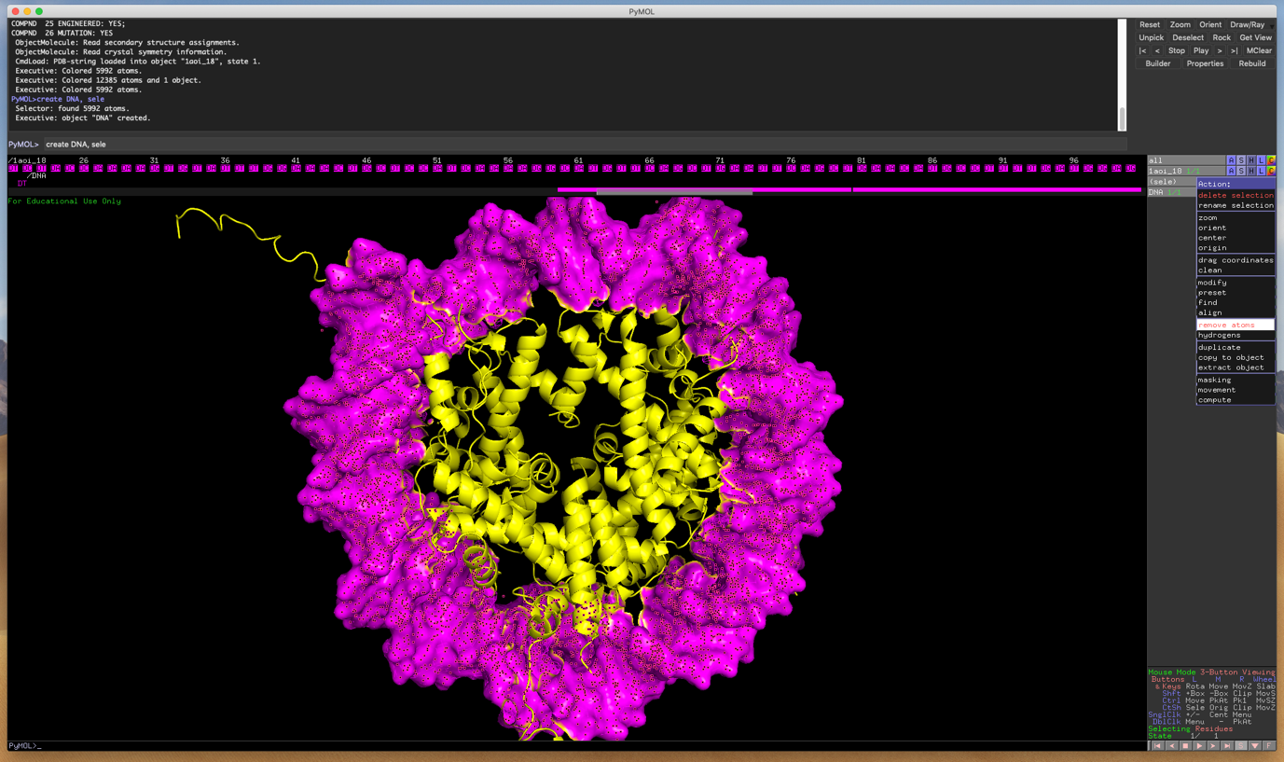

Or 2) Select all the residues for the histone octamer and crete a new item as above by typing “create octamer, sele”. Note the protein (yellow cartoon) is now selected in the image below.

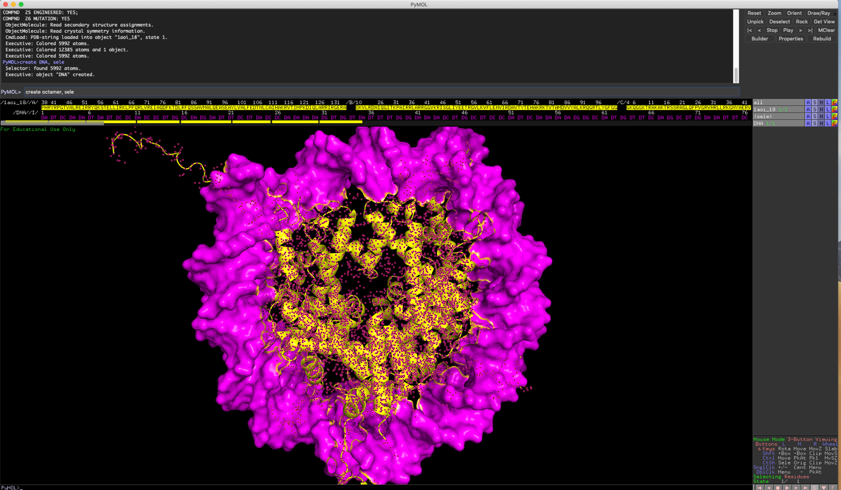

This will generate yet another item called “octamer” and will only have the atoms corresponding to the protein portion of the nucleosome. You will now also see that the sequence bar has the sequences for the 3 different items.



Deselect your original PDB file opened by clicking on it on the RHS. You can now also remove the original PDB file if you wish and ONLY work with the new “DNA” and “octamer” items (Click on the “A” button next to 1aoi_18 and choose “delete object”. I didn’t do this below). You can now change the representation of the DNA to mesh/surface and it will no longer be affected by the protein portion of the original PDB file:

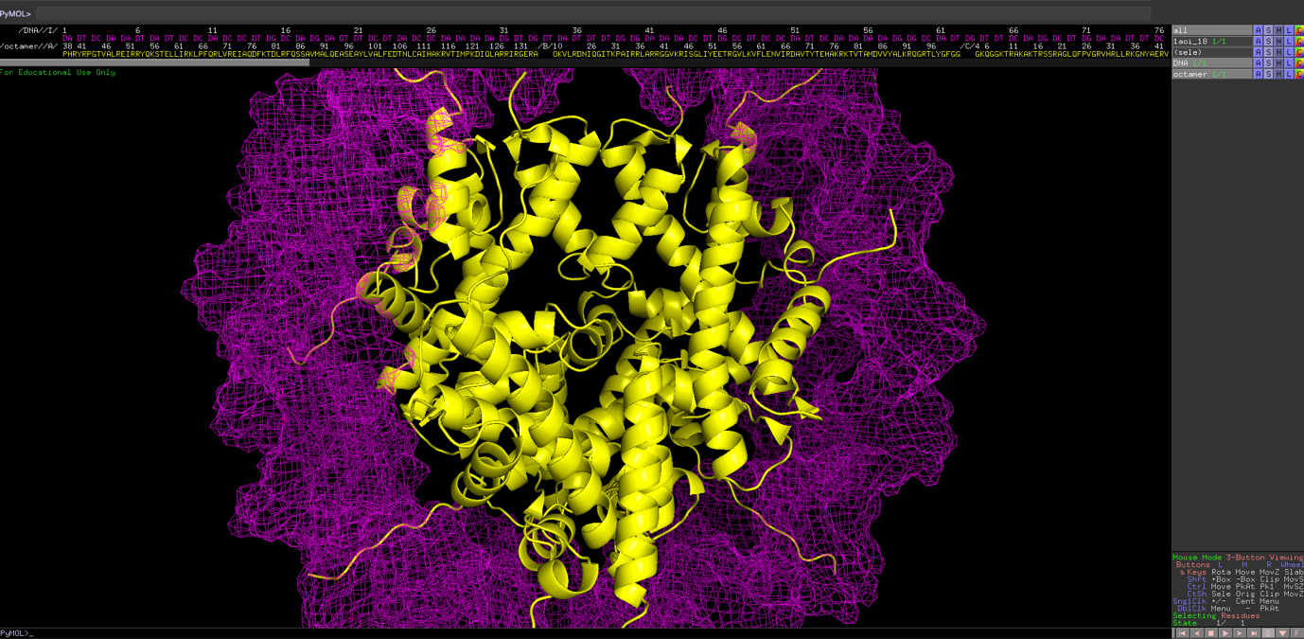

If you want to see mesh AND cartoon for the DNA, click on the “S” button next to the DNA item and select “cartoon”. Do not go through the “as” menu- by doing so, you will ONLY show as cartoon.

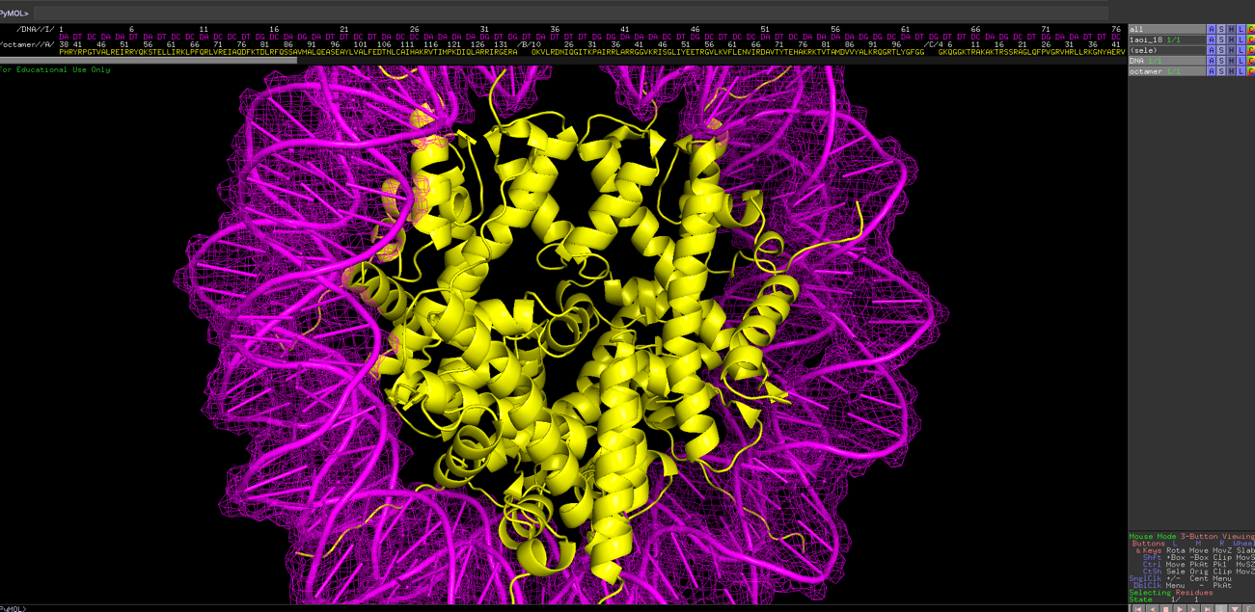

* **For skinnier helices**, type “set cartoon_oval_length, 0.8” in the command line:

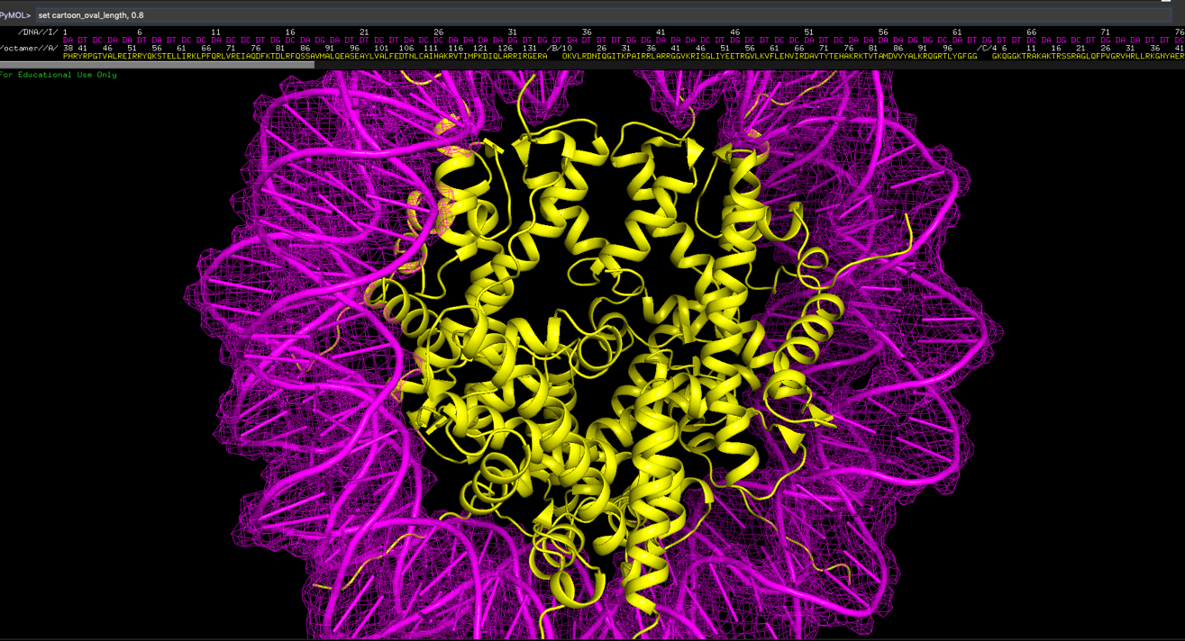

To change back to default, type “set cartoon_oval_length, 1.2” in the command line

* **To change the thickness of loops** type: “set cartoon_loop_radius, 0.5” in the command line

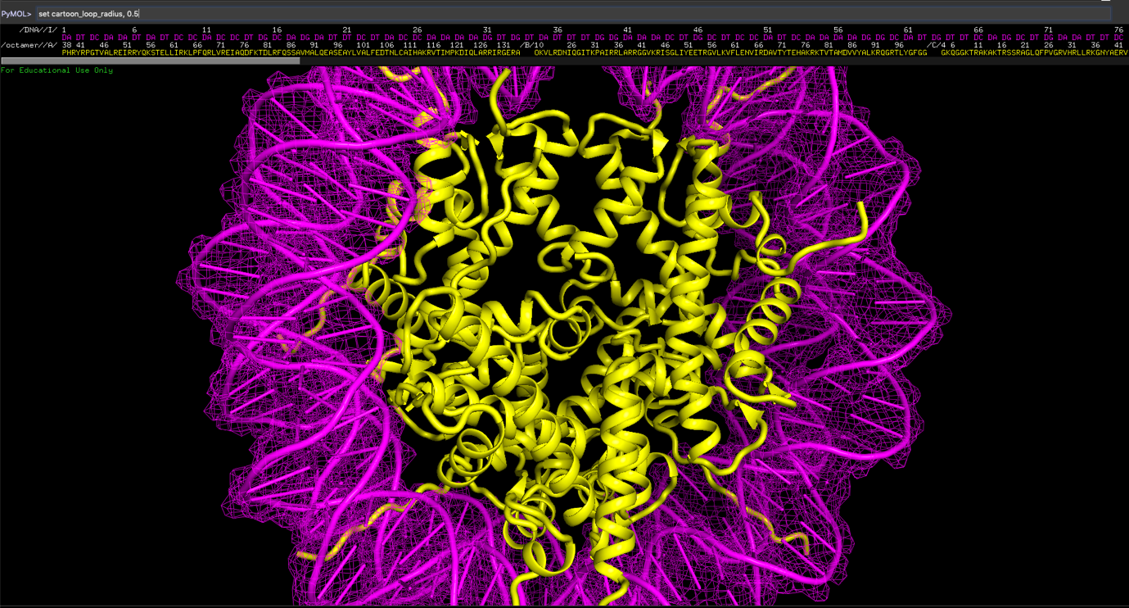

To change back to default, type “set cartoon_loop_radius, 0.2” in the command line.

* If there’s **missing residues** eg. in a loop region of your protein, and PyMOL draws a **dashed line** in place of the missing region, you can get rid of this by typing “set cartoon_gap_cutoff, 0” in the command line.
* If you want to **highlight a specific residue** that has N and O atoms, you can show the side chain of that residue by selecting it on the sequence bar and then clicking the “S” button next to the (sele) item and then selecting “side chain” 🡪 “sticks”. Again, do NOT go through the “as” menu.

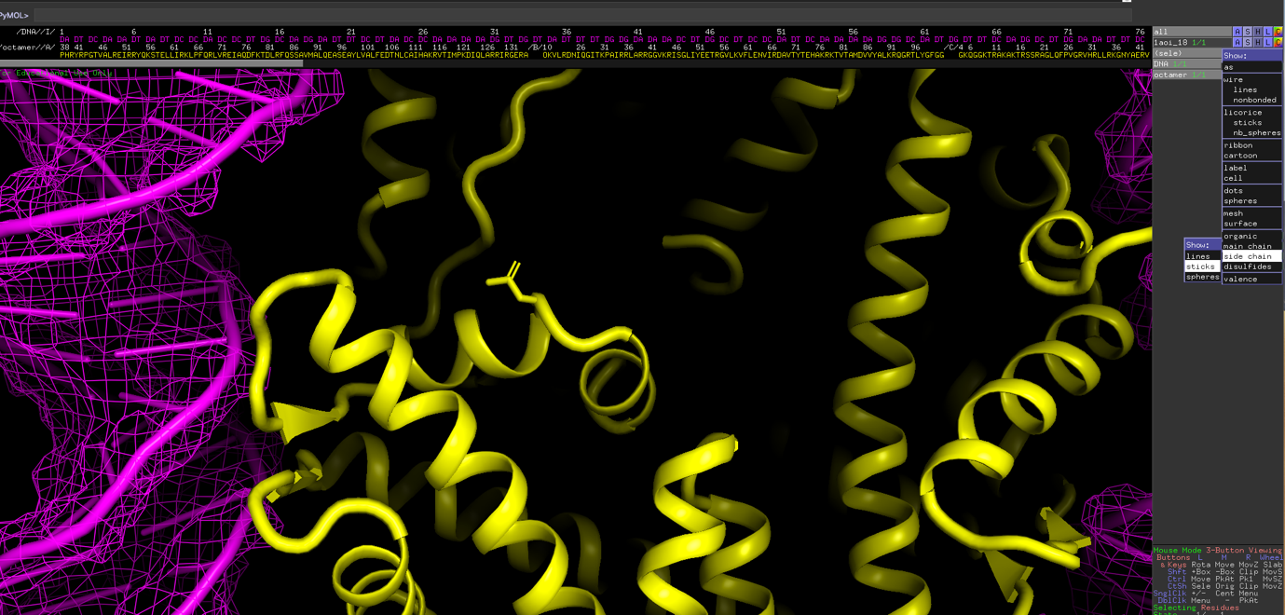

Then to show the N and O atoms in blue/red, respectively, click on the “C” button next to the “(sele)” item, hover your mouse over “by element” and choose the top option:

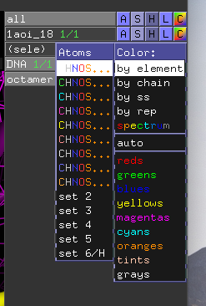

Your residue should now look like this:

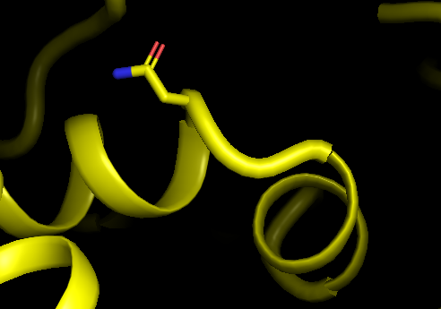

And there’s a lot more you can do in PyMOL. See the wiki if you are feeling creative ☺

<https://pymolwiki.org/index.php/Main_Page>